**SL Unit 2** **– Computer Organization**  
Quiz 2

|  |  |  |  |
| --- | --- | --- | --- |
| **Question 1** | | | |
| Objectives: | 2.1.12 | Exam Reference: | Nov-15 3 |

Construct a truth table for the following Boolean expression.  
  
 (A and B) nor C [3]

|  |  |  |  |
| --- | --- | --- | --- |
| **Question 2** | | | |
| Objectives: | 2.1.10 | Exam Reference: | May-15 9 |

In an 8-bit register, state the binary representation of the hexadecimal number 3B. [2]

|  |  |  |  |
| --- | --- | --- | --- |
| **Question 3** | | | |
| Objectives: | 2.1.1, 2.1.6,2.1.9 | Exam Reference: | Nov-15 8 |

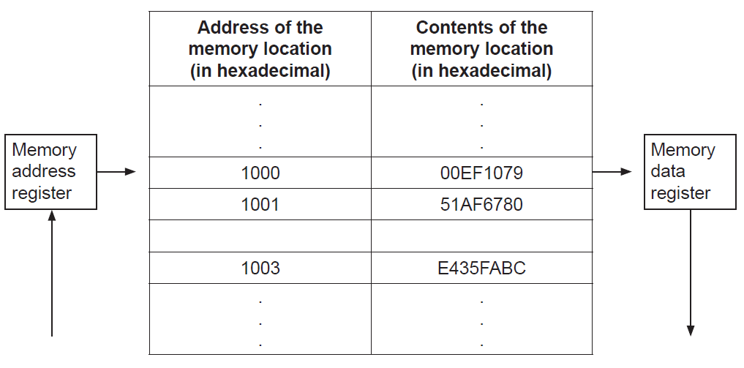The following diagram shows the structure of the random access memory (RAM).

1. Calculate the number of bits in each memory location. [1]
2. Calculate the number of bytes in each address. [1]
3. Outline the function of the:
4. memory address register [2]

1. memory data register. [2]

1. (i) Identify two functions of the operating system. [2]

(ii) State where the operating system is held when the computer is turned off. [1]

The machine instruction cycle refers to the retrieval of an instruction from the RAM, and  
 subsequently decoding, executing and storing the result.

1. (i) Construct a diagram to illustrate the structure of a central processing unit (CPU),  
    clearly showing the flow of data within the CPU. [4]

(ii) Identify the part of the CPU which performs decoding. [1]